# **Application**

Our sql database, “strongman_comp”, application is used for historical Reference to the 2019 strong man competition. The database lists all men and women who had participated in the competition including Points for all the events that took place correlated to each competitor. There are 3 tables labeled competitors, stong_men and strong_women. The database would be used for a web service. This would allow for hundreds to thousands of people to log in at once and for a lot of data in and out, although the data would not change the amount of information pulled from a web user is what would be calculated. Users would interact through an open website that would allow them to move between the tables. In total there are 17 competitors, 4 events and three weight classes. You are able to see who got what place based on the amount of points each competitor got.

# **Data Set Description**

This data set we took from the Google sheets file created by the 2019 strongman competition results from the following URL [STRONGMAN LEGION SPORT FEST RESULTS.xlsx - Google Sheets](https://docs.google.com/spreadsheets/d/1tQX5bsH2vPOQQ_-X3Z6bQtLZj-NY_r6a/edit#gid=72185745). Our Mysql database is made to be a historical website reference that runs in the background and a website would pull our information up to the website depending on how the website programmer would pull our mysql databases. Our database was designed to hold 3 tables, one for the competitors, another for men with their individual events with their individual event points and another separate table for women with their points in each of the events. The competitors table holds the user ID, first name, last name and weight class of the competitor. The men's table holds all of the points based on the individual for each competition and the women's table also does this but only for the women.

The customized tables will be made from the database mysql code found in the github link in the walkthrough and they will be created directly from information we got from the google sheets.

# 

# **Database Design**

Our database has three tables labeled competitors, strong_men and strong_women.

The competitors table is a child table that holds the foreign key which is labeled user_id. The strong_men and strong_women are parent tables that pull from the competitors table using user_id as its primary key. You can find all folders and documents for this project at the website [ablegriego/strongmen-competition (github.com)](https://github.com/ablegriego/strongmen-competition).

**Competitors:**

The competitors table is made up of four columns user_id, first_name, Last_name and weight_class. “Int” stands for integer and is put in the row of user_id because it expects a number in the values area. The “varchar(45)” expects a value with words that can go to 45 characters. The primary key is what's used to communicate with other tables. Each table also has an “engine” where you store the table and a “charset” which is how it translates the table. Each table has the same “engine” and “charset”.

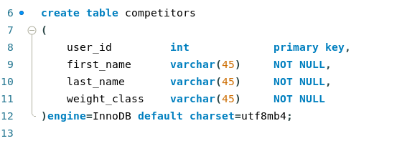

**Strong_men and strong_women:**

The strong_men table has 10 columns normally you would add the same columns from another table like first_name, Last_name and weight_class because the primary key would join all the columns but ours are there as redundancy but are not necessarily needed.

The other columns added to this are the events that hold the point value each competitor got in that event. The constraint on the bottom tells the strong_men and strong_women table to use competitors as its foreign key which is what would normally help pull first_name, Last_name and weight_class columns and connect all the tables together.

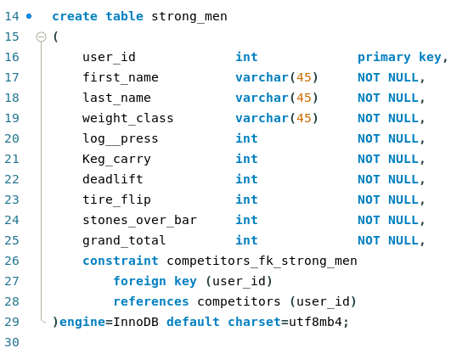

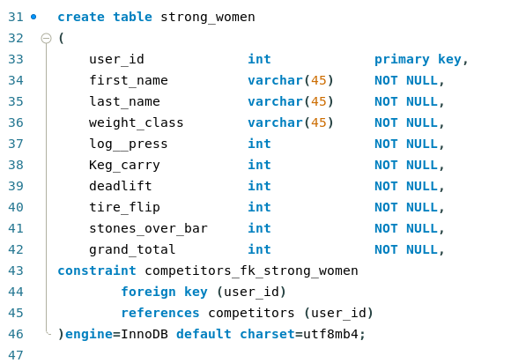

**Inputs:**

Our data was all manually typed and put into the database using inserts.

When creating an insert you first choose the table you want to insert the data into followed by the columns you would like that data to go to. Then after the “Values” command, in the same way you listed and ordered your columns you will list and order your values so that the value you want inserted corresponds to the column. This way your values don't end up in the wrong column.

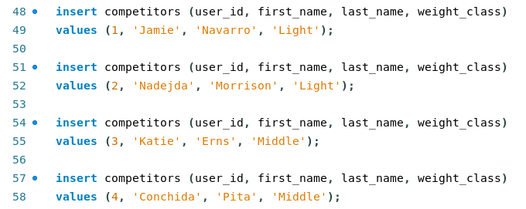

**Reloading the database:**

When reloading the database the “drop database if exists” command allows you to reload the database without causing an error. If the database were still to exist and you tried to reload the database without first deleting the old one you would get an error telling you the database already exists and that you can't reload the database again because of duplicate values.

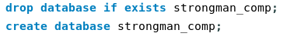

**The tables:**

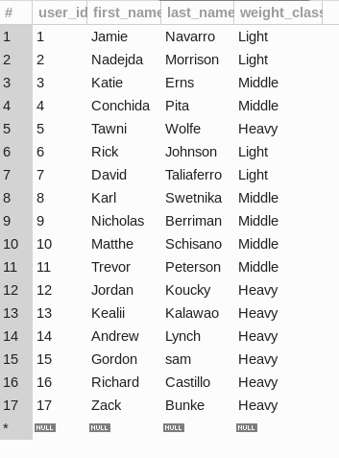

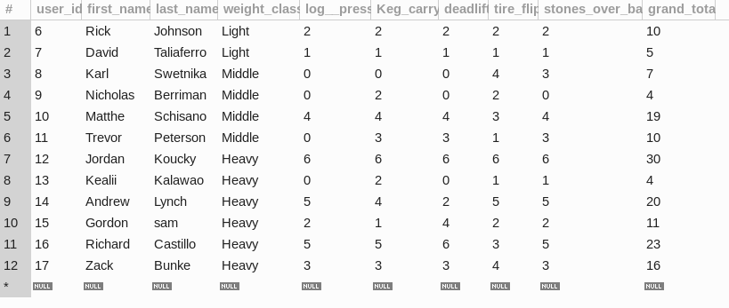

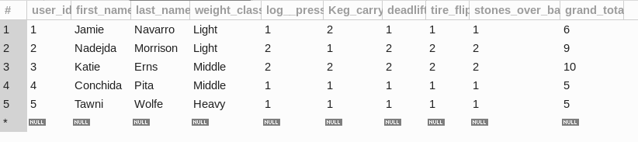

# 

# **Data Loading**

**Step 1:** go to the following website[ablegriego/strongmen-competition (github.com)](https://github.com/ablegriego/strongmen-competition)

**Step 2:** Now you can press on the green button that says “Code”. Select download zip file.

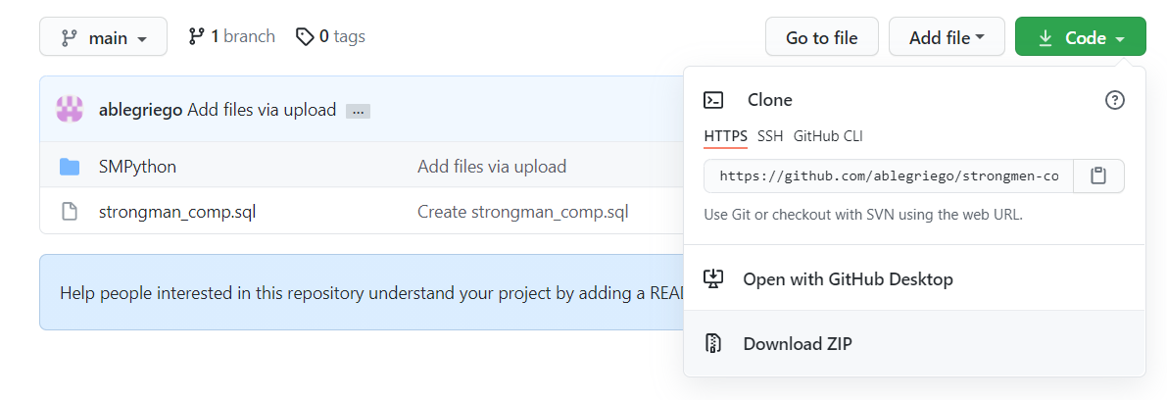

**Step 3:** Go to your file explorer and extract the from the zip file you downloaded.

**Step 4:** Open your extracted files until you see the “strongman_comp” sql file, right click on the file and select “open with”. Then select “MySQL workbench”.

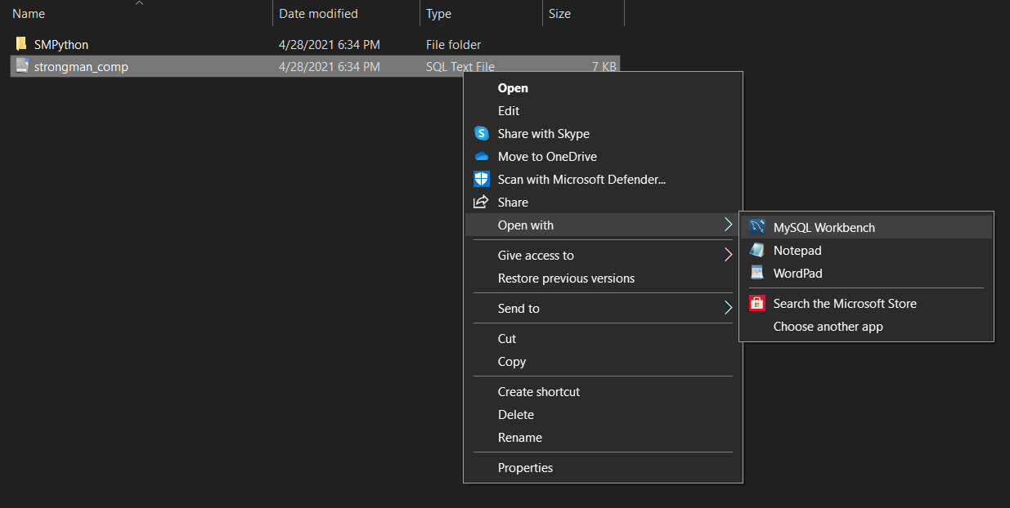

**Step 5:** Once your MySQL Workbench pops up, click on the yellow lighting bolt to run the script.

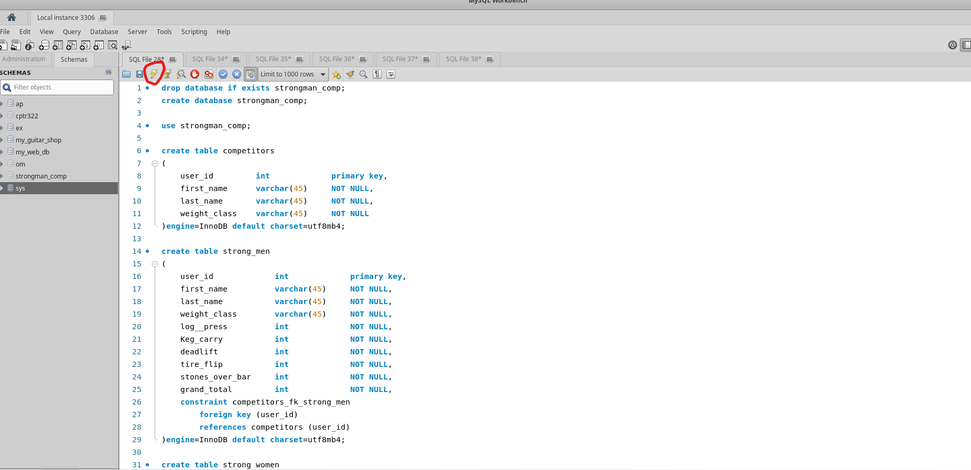

**Step 6:** Refresh your Schemas tab by clicking on the rotating arrows in the Schemas tab. The “strongman_comp” database will pop up.

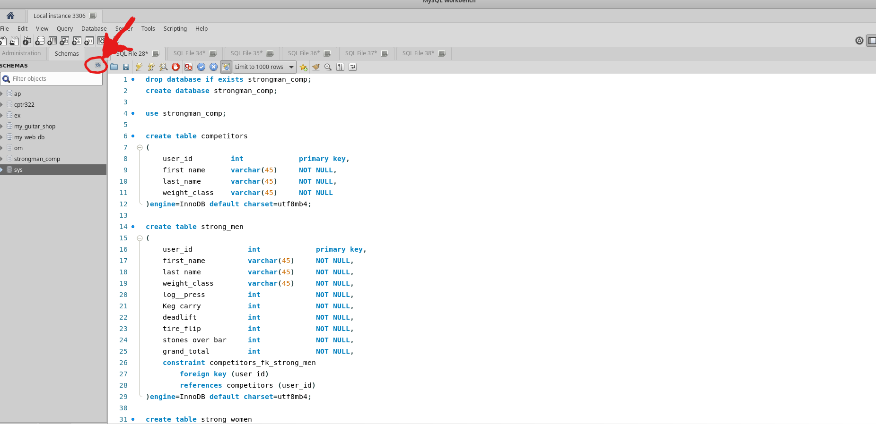

**Step 7:** run the following script in a new tab:

use strongman_comp;

select *

from competitors

Push the yellow lighting bolt again and you should get these results:

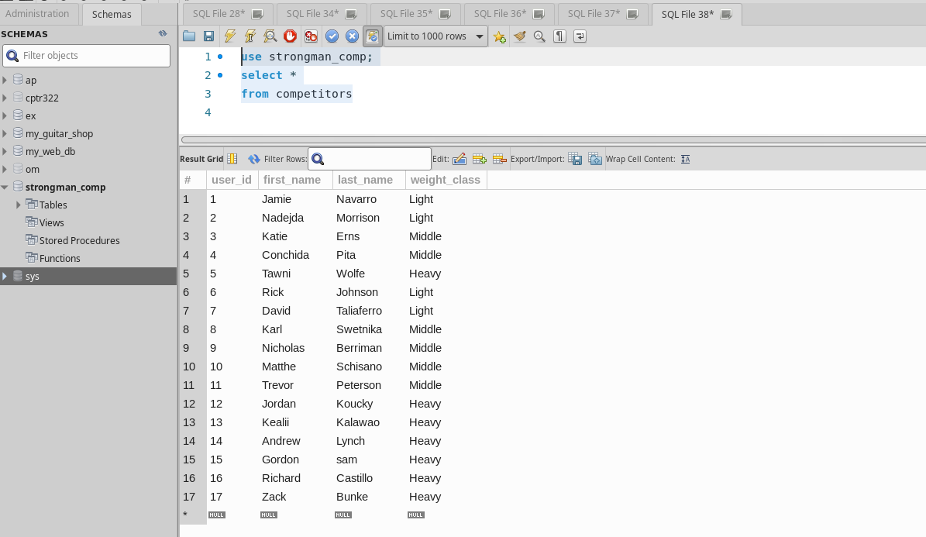

# 

# **Example Programing**

For this tutorial you will need to have visual studio code to run the program.

**Step 1:** Once you have followed the Data Loading part, you then go to this link:

**Step 2:** Open the SMPython file inside your file explorer then select both login.txt file and the strongman_comp.py and right click.

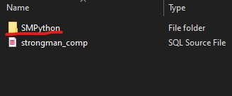



**Step 3:** Open the file with visual studio code.

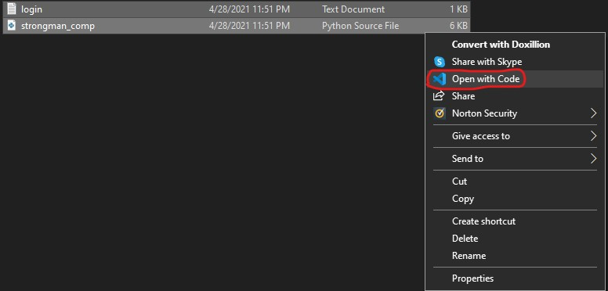

**Step 4:** Once you open Visual studio code, go to the run menu and click on add configuration

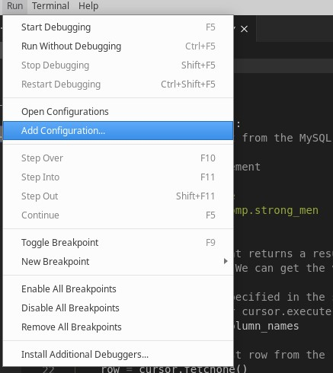

**Step 5:** Then on the Debug Configuration select the first tab Python File.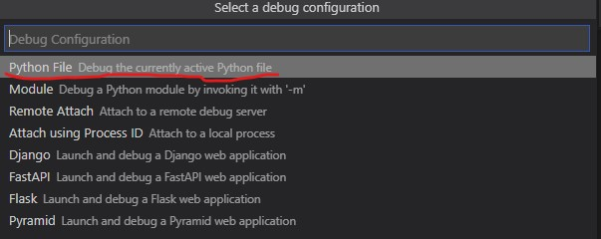

**Step 6:** Then it should open a launch.json file, then in between program and console functions add the args function listing in between brackets and parentheses “count” and “competitors” as shown below.

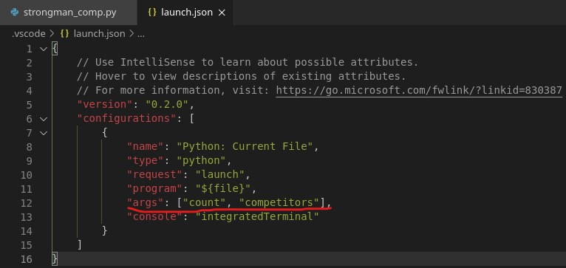

**Step 7:** Then save the launch.json file and then go back to the run menu and click on Debug and the terminal should pop up.

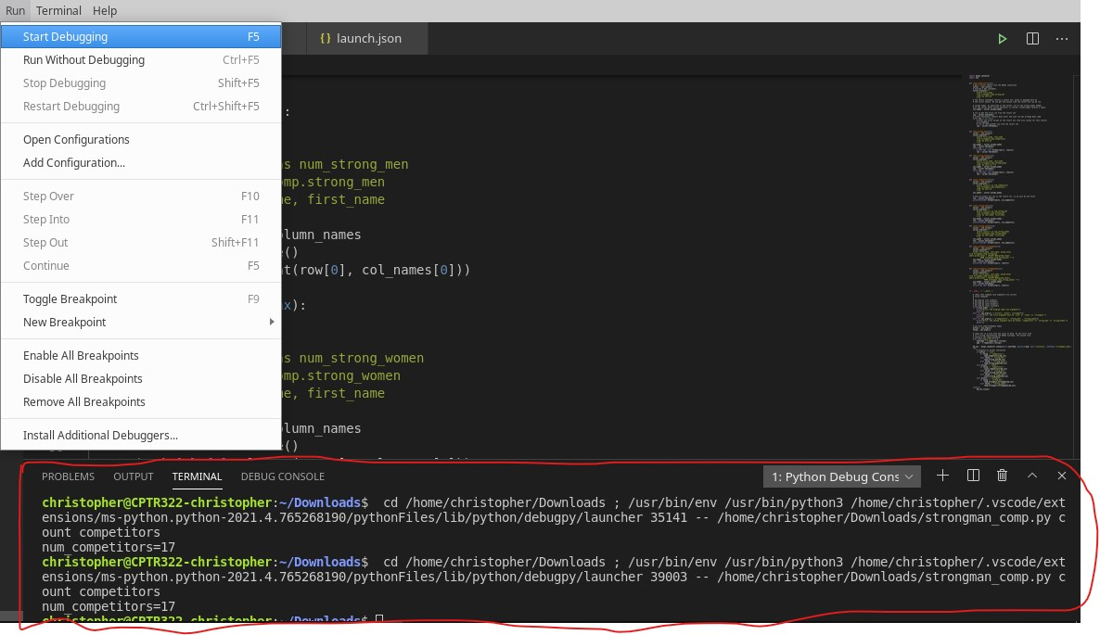

**Step 8:** Make sure that your directory is on the file where you stored the strongman_comp folder then type: python3 strongman_comp.py list competitors hit Enter and you should see a list of the competitors from their first name.

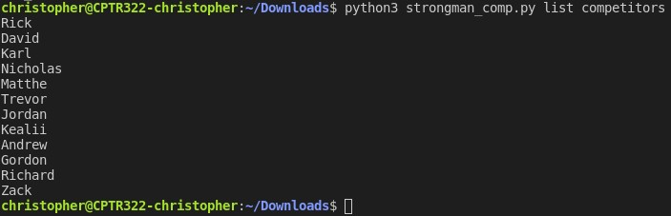

Then you can use the list function on strong_men and strong_women and you get this list:

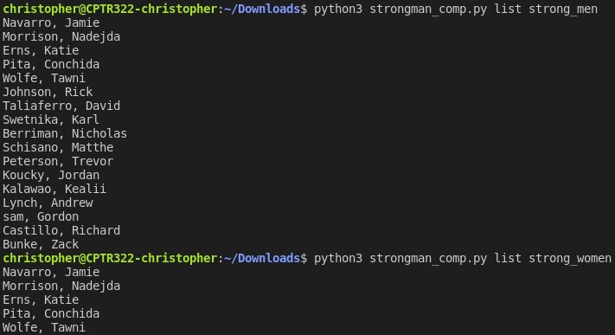

Then you have the count function with the competitors, strong_men and strong_women that counts the number of competitors, strong men and strong women from each table.

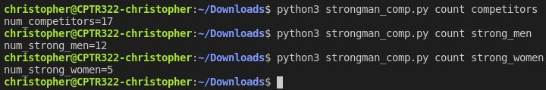

Then you also have the strongest function which lists the strongest man and woman from each table based on their highest grand total.

